INTERNET OF THINGS – GROUP2

PROJECT 10. TRAFFIC MANAGEMENT SYSTEM

OBJECTIVES:

Creating a traffic control management system using sensors, cameras, Arduino, Raspberry Pi, and a cloud simulator involves multiple components and steps. Below is a high-level overview along with sample code snippets for guidance. This is a simplified example and real-world systems require careful design, testing, and potentially certification depending on the application.

COMPONENTS REQUIRED:

1. Raspberry Pi (with Raspbian OS installed)

2. Arduino Board

3. Sensors (e.g., ultrasonic sensors for vehicle detection)

4. Camera module

5. Cloud simulator (for ex: Azure IOT cloud simulator)

STEPS TO BE FOLLOWED:

STEP1.Setting Up Hardware:

- Connect the sensors, camera, and Arduino to the Raspberry Pi as per their datasheets or manuals. Ensure they're powered properly.

STEP2.Install Required Libraries and Software:

- If you're using additional sensors, you might need to install libraries for them. For example, for an ultrasonic sensor, you'd use something like the GPIOZERO library on the Raspberry Pi.

STEP3. Writing the Arduino Code:

- The Arduino code will handle sensor data and potentially control hardware components like traffic lights.

STEP4. Setting Up Cloud Simulator:

- Create an account on a cloud service (e.g., AWS, Google Cloud) and set up a project with IoT capabilities.

STEP5. Sending Data to Cloud from Raspberry Pi:

- Use the cloud service's provided libraries or SDKs to send data from the Raspberry Pi to the cloud. This could be sensor data or images captured by the camera.

STEP6.Implementing Traffic Control Logic in Cloud:

- In the cloud, process the received data (e.g., apply machine learning for object detection). Based on the processed data, decide when to change traffic signals.

STEP7.Sending Control Signals from Cloud to Arduino:

- Send control signals from the cloud to the Arduino through the cloud service. This could be done using MQTT or other communication protocols.

STEP8. Integration and Testing:

- Integrate all components and thoroughly test the system.

Writing the Python Code for Raspberry Pi:

#Sample Python Code for Vehicle Detection using Ultrasonic Sensors:

import Distance Sensor

from time import sleep

sensor = Distance Sensor (echo=17, trigger=4) # Example GPIO pins

while True:

distance = sensor. distance * 100 # Convert to cm

print (f ’Distance: {distance:.2f} cm')

if distance < 30: # Adjust as needed

# Vehicle detected, implement traffic control logic here

pass

sleep (1)

# Sample Python Code for Image Processing using Camera:

python

from pi Camera import Pi Camera

from time import sleep

camera = Pi Camera ()

def capture_ image (file_ name):

camera. Start _ preview ()

sleep (2) # Allow time for the camera to adjust

camera capture(filename)

camera. Stop _ preview ()

capture_ image ('test_image.jpg')

CONCLUSION:

This is a simple innovation of traffic control management. Here is a step by step procedure for controlling a traffic light using three LED’ S (Yellow , green ,red).

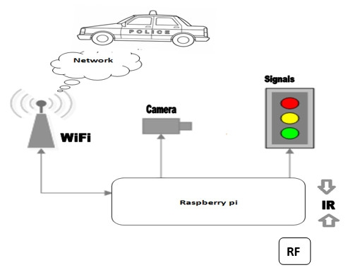

BLOCK DIAGRAM:

